Homework 2
Histogram Equalization
The objective of this assignment is to understand and implement the concept of histogram equalization to enhance the contrast of a digital image.
You will need to apply both the Global Histogram Equalization and Local Histogram Equalization to the same grayscale image, implement them in Python, and document any observations in your report
This assignment allows the use of the OpenCV API: equalizeHist(), but you will only receive basic score. If you can implement the underlying logic yourself, you will earn a higher score.
The following is a diagram included in the report, using Global HE as an example.
Bonus: Implementing any Histogram Equalization algorithms mentioned in the course will provide additional credit.
 | Before Global HE | After Global HE
images | 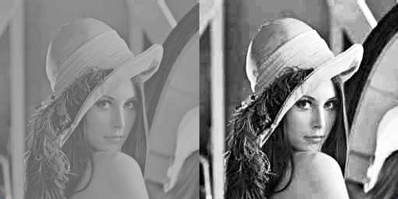
Histogram | 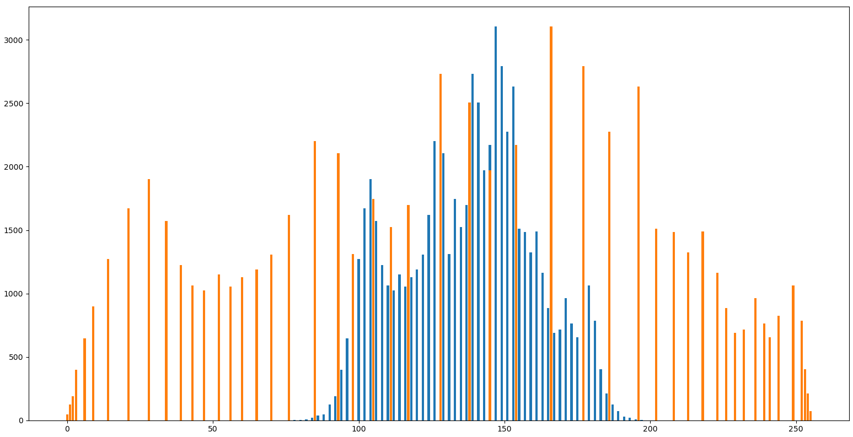
The report must contain the following(Submit the PDF)：
1. Screenshots：Display the original image, the image after Histogram equalization
 | Before Global HE | After Global HE
images | 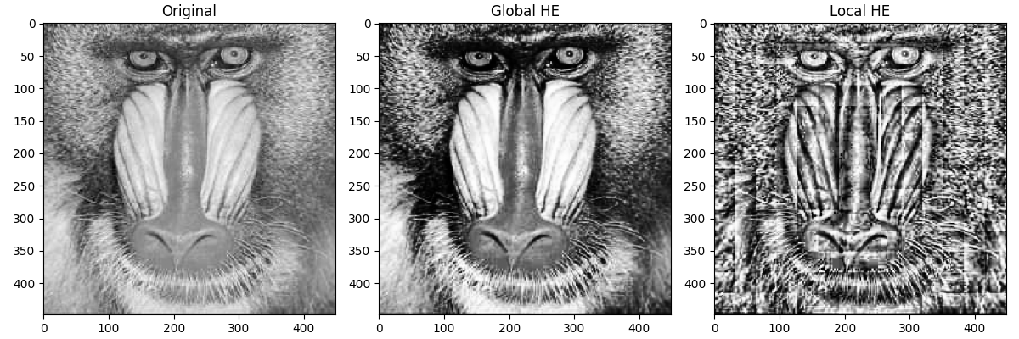
Histogram | 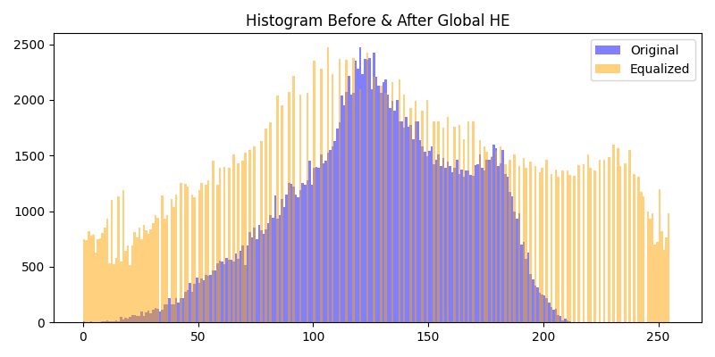

 | Before Global HE | After Global HE
images | 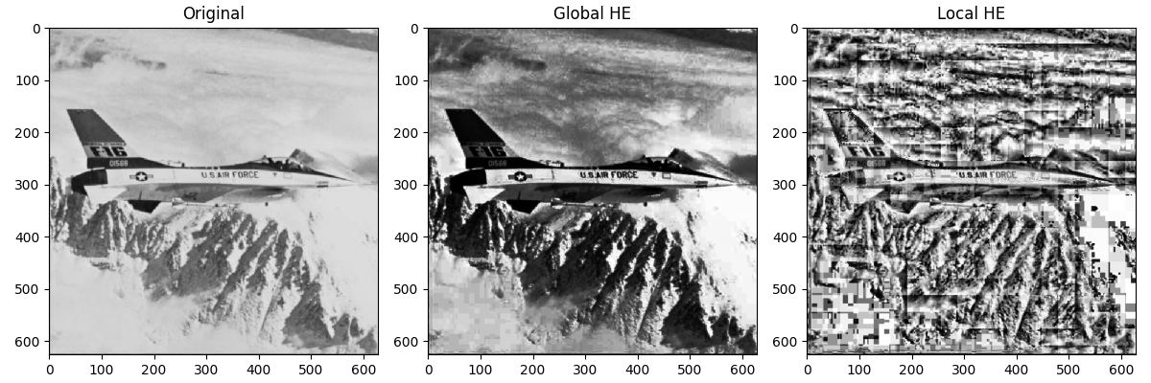
Histogram | 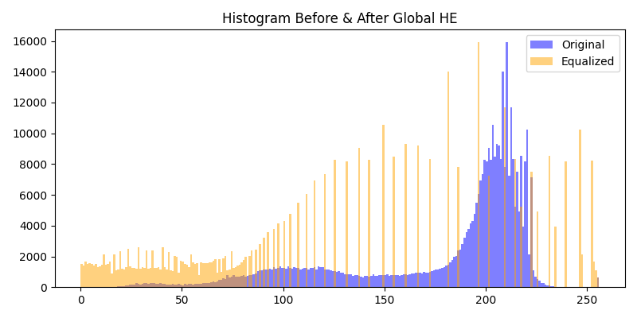

2. Explain：Your method (if you have other try) with experiment
In this assignment, I implemented two enhancement pipelines: Global Histogram Equalization (GHE) and Local Histogram Equalization (LHE). The goal was to compare how these two strategies influence contrast enhancement under different illumination and texture distributions.
Global Histogram Equalization computes a single intensity distribution for the entire image and applies a remapping based on the cumulative distribution function. This spreads pixel values across the full dynamic range, significantly improving overall contrast. It performs well when the image suffers from general low contrast or uniform lighting.
Local Histogram Equalization divides the image into small tiles and applies histogram equalization independently to each one. This allows the method to adapt to local brightness conditions and reveal fine details in textured or unevenly lit regions. In the experiment, details such as the baboon’s fur patterns and surface structures on the F-16 became more pronounced. However, this method may produce block artifacts or amplify noise when the tile size is small or the illumination varies sharply.
I tested both methods on the Baboon and F-16 images, analyzing histogram distribution changes, visual enhancement effects, and the smoothness of transitions. The comparison demonstrates that global equalization emphasizes overall contrast, while local equalization enhances fine structures but requires careful control to avoid artifacts.
3. Discussion：interesting finding, difficulties you encountered, insights you observe
GHE significantly increases global contrast, but may wash out bright regions.
LHE reveals fine textures and handles uneven lighting better, though it may produce block artifacts.
The main difficulty was controlling the tile size in LHE—too small increases noise, too large reduces detail enhancement.
An important insight is that GHE improves overall dynamic range, while LHE boosts micro-contrast.
During the experiment, I observed several interesting behaviors. Global Histogram Equalization significantly broadens the intensity distribution, improving contrast but sometimes causing bright regions to become overly stretched, which may lead to detail loss. In contrast, Local Histogram Equalization highlights fine textures more effectively, especially noticeable in the baboon’s fur and the aircraft’s surface details.
Several difficulties emerged during the process. The local method sometimes produced visible block boundaries because each tile undergoes different enhancement levels. This can result in brightness jumps or exaggerated sharpness. Additionally, noise in darker regions tends to be amplified, requiring careful adjustment of tile size and smoothing strategies.
From this study, I concluded that global equalization is suitable for boosting overall contrast, while local equalization is more appropriate for images containing rich textures or non-uniform lighting. However, both methods involve trade-offs. Global equalization may sacrifice local detail, while local equalization can cause inconsistency across blocks. For this reason, more advanced techniques such as CLAHE are often preferred in practical systems to avoid block artifacts.

